**Federal Contract # DTFH61-17D00001 – Task Order #2**

**LONG-TERM BRIDGE PERFORMANCE PROGRAM**

PROGRESS REPORT NO. 6

Report Period: March 1, 2018 – March 31, 2018

Prepared For:

**Federal Highway Administration**

Prepared By:

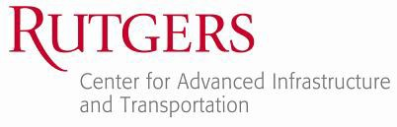

**A. Account of work performed in this period**

* 1. **Coordination and Meetings Between the Contractor and FHWA LTBP Team**

The Rutgers team attended a meeting at FHWA Turner Fairbank on 3/6. The purpose of the meeting was to meet with the HDR team and help FHWA and the HDR team to prepare for the data collection contract.

Staff Engineer: 16 hours

* 1. **Develop LTBP Program bridge performance strategic research matrix**

March 2018 work consisted of developing the final proposed framework for the Strategic Research Matrices. This work included developing review process and protocols (Task 2.2.3), graphical representation (Task 2.2.4), SRM functional requirements (Task 2.2.1), topic refinement and keyword development (Task 2.2.2) for automated search. Returning to earlier subtasks in the workflow was necessary due to changes in scope to better align the project with FHWA priorities based on the February meeting at Turner-Fairbank. Work in March also began to cover ground that was to be found under the objective in Task 2.3. Test research extraction programs were undertaken with prototype software (Task 2.3.1) in order to refine the SRM framework. More details about each task can be found later in this section.

Task 2.2.1 - Identification of Review Objectives: Functional requirements for the SRMs were detailed as part of this subtask. This process was iterated with work on other subtasks. Details of the findings of this task will be found in the Task 2.2 report, due end of April 2018.

Task 2.2.2 - Development of Strategic Research Matrices Framework: An initial list of keywords to be used by the research extraction software with the domain knowledge experts at NJIT. The initial basis for these topics was the conceptual framework of Bridge Performance; this was developed first via the Data Gap Analysis task, under LTBP Task Order 2. The bridge performance categories, inputs, and attributes were then subdivided into research topics, such predicting freeze-thaw behavior, or concrete mix design. Work is ongoing to develop a comprehensive list of keywords, context keywords, and other terms useful for automating web searches for research.

Task 2.2.3 - Development of Review Protocol: Further work was performed to develop a comprehensive framework for software search of research. Constraints were developed for research sources. An investigation was undertaken to discover the availability of funding information for state DOT-based research. Work was undertaken to determine the best underlaying technologies for the development of a web-based SRM.

Task 2.2.4 - Development of Initial Visualization Concepts: Graphical mockups were developed for the SRMs. Whiteboarding sessions allowed the research team to refine these concepts. A sample of the concepts developed during this stage can be found in Appendix A.

Co-PI: 8.5 hours

Project Engineer: 215.5 hours

Staff Engineer: 172.5 hours

Technician: 38.74

Project Support: 17 hours

* 1. **Conduct training for all field personnel on LTBP Protocols**

No work was performed for this task.

* 1. **Development of data collection protocols and RABIT-CE operations manual**

Task 4.2.1. Instrumentation Protocols – After the submission of review comments to the Pennoni, the Rutgers team continued working on some of the very important protocols (mainly instrumentation design protocols). Meanwhile, the Pennoni team continued working on the revisions and submitted the completed parts in multiple steps.

Task 4.2.2. Legacy Data Mining Protocols – After discussion during the February 23rd meeting at the FHWA- TFHRC office, the Rutgers team finalized a list of several issues (beyond the scope of the current contract) to be corrected at the final drafts (see Appendix B). To that extent, the Rutgers team focused working on that additional task and analyzed the data extracted from the 1200 bridge documents, which has been completed through the last contract. Through this analysis, it was possible to locate the protocols fields which have been rarely or never filled up.

Task 4.2.3. RABIT-CE Operations Manual - After the submission of review comments to Infratek, the Rutgers team continued working on the contents of the proposed Validation Plan. Multiple discussions were also made with the Infratek (as they havemore experience) to complete the Validation Plan. At the last days of March, the Rutgers team received the review responses from the Infratek.

Co-PI: 3.5 hours

Subject Matter Expert: 13 hours

Staff Engineer: 165 hours

Senior Engineer: 68 hours

Project Engineer: 205.5 hours

Technician: 23.52

Project Support: 12 hours

* 1. **Legacy Data Mining data extraction**

The Rutgers team accomplished the following during the month of February:

* Data extraction were performed throughout the month for the bridge plans provided. It should be noted that these data extraction being performed by everyone in the LDM group will take up the majority of the groups effort to complete.
* Continued to work on extracting the BLOB (Binary Large Object) files for implementation into Bridge Portal. A large portion of the team’s efforts will lay in the data extraction for the immediate future.
* Quality control and quality assurance was provided for the data extraction performed this month and last month by reviewing the data collected by the students on the data extraction excel input sheet.
* Cataloguing of all bridge documentation collected that is currently being used for LDM as well as the analysis of statistics found from this such as percentage collected/missing.
* Maintenance records from the bridges in each state in which bridge documentation was collected for LDM were carefully reviewed in order to look more precisely as to exactly what kind of detailed items were included in these reports, what important items were missing, and the overall quality of the documentation provided to us from each state.
* In addition to providing charts/data/graphs of all of the bridge documentation and maintenance records analyzed, a written portion of the explaining the results found from this study were also provided.

CO-PI: 4.5 hours

Staff Engineer: 156.5 hours

Technician: 25 hours

Project Support: 6 hours

* 1. **Organize, conduct, and participate in LTBP workshops and meetings**

No work was performed for this task.

* 1. **Publications, website, communications, and technical assistance**

The Rutgers team prepared the electronic version of the monthly progress report and submitted it to FHWA. Moreover, the Rutgers team developed a MS Project file showing the project milestone and submitted it to FHWA.

Moreover, the Bridge Intelligence team replied to numerous FHWA’s requests. The detail is in the subcontract section.

Co-PI: 31.5

Project Support: 20 hours

**B. Work to be accomplished during the next period**

* 1. **Coordination and Meetings Between the Contractor and FHWA LTBP Team**

The Rutgers team will reach out to the FHWA team to set up a monthly meeting.

* 1. **Develop LTBP Program bridge performance strategic research matrix**

The Rutgers team will continue the formalization of the SRM framework. The Task 2.2 report will be developed and delivered to COR in April.

* 1. **Conduct training for all field personnel on LTBP Protocols**

No work is planned under this task for the next reporting period as of now. However, FHWA might ask the Rutgers team to do a round of training for the HDR team in March.

* 1. **Development of data collection protocols and RABIT-CE operations manual**

Task 4.2.1. Instrumentation Protocols – the Rutgers team will receive all the remaining items from Pennoni and will finalize the protocols. The completed drafts will be submitted to the COR by April 25.

Task 4.2.2. Legacy Data Mining Protocols – the Rutgers team will finalize all the remaining items from the last task, which was additionally assigned during the February 23rd meeting at the FHWA- TFHRC office. The completed drafts will be submitted to the COR by April 25.

Task 4.2.3. RABIT-CE Operations Manual – the Infratek and Rutgers teams will work collaboratively to finalize the manual. The completed manual will be submitted to the COR by April 25.

* 1. **Legacy Data Mining data extraction**

The Rutgers team will continue with the data extraction from bridge documentations for the bridges that are assigned by FHWA. In addition, the team will perform QA/QC to make sure that the content being recorded in the main excel file is of high quality. The team will continue to update the main excel sheet with minor improvements in order to increase efficiency.

* 1. **Organize, conduct, and participate in LTBP workshops and meetings**

No work is planned under this task for the next reporting period.

* 1. **Publications, website, communications, and technical assistance**

The Rutgers team will prepare the electronic version of the monthly progress report and will submit it to FHWA. Moreover, the Rutgers team will submit the updated MS Project file to FHWA.

The Rutgers team will work on the tasks related to Bridge Portal as they are requested by FHWA.

**C. Problems/Recommended Solutions**

No problems encountered during this period.

**D. How the results of the work performed supports one or more of the FHWA, DOT and LTBP Goals**

The following is a summary of how the work performed on the primary tasks of this task order contribute to meeting the FHWA, DOT, and LTBP program goals.

**Task 2 - Develop LTBP Program bridge performance strategic research matrix**

Fundamentally, the SRMs aim to link the LTBP program to the larger research community. By placing the LTBP efforts in this larger context, the program will be able to identify potential synergies and collaborative opportunities as well as any overlaps that may exist. This will both increase the cost effectiveness of the program as well as the program’s impact on bridge engineering practice through clearly showing how the LTBP program contributes to the overall bridge performance research landscape.

**Task 3 - Conduct training for all field personnel on LTBP Protocols**

At the heart of the LTBP program’s data collection effort is the requirement that data be obtained in a consistent and reliable manner across the breadth of the program. Variations in collection techniques or unreliable practices would pollute the data streams and greatly limit the ability of the program to meets its goal of improving our understanding of long-term bridge performance. Activities under this task aim to ensure that the data collection efforts of the LTBP program are executed by teams with the required expertise to obtain consistent and reliable data.

**Task 4 - Development of data collection protocols and RABIT-CE operations manual**

Similar to the training work being conducted under Task 3, this task is also involved in ensuring consistent and reliable data collection throughout the program. Specifically, this task will develop additional protocols and operations manuals that specify best-practice approaches for data collection.

**Task 5 - Legacy Data Mining data extraction**

In addition to ensuring consistent and reliable data collection efforts, the overarching goal of the program is also dependent upon the completeness of the data collection efforts. This task contributes to this through the collection of available legacy data. This data not only provides a means to ensure field data collection efforts are carried out efficiently (i.e. on bridges best suited to meeting the program’s goals) but also provides context to the data to help explain observed trends and correlations (and thus further our understanding of long-term bridge performance).

**E. Purchases and Rentals**

Nothing was purchased during this period.

**F. Travel Details for Reporting Period**

None.

**G. Current and Cumulative Expenditures (cost shown includes benefits and overhead)**

|  |  |  |
| --- | --- | --- |
| **Institution** | **Current Expenditures**  **2/1/2018 – 2/28/2018** | **Cumulative Expenditures**  **10/1/2017 – 2/28/2018** |
| Rutgers, the State University of New Jersey | $ 77,219.94 | $ 292,582.94 |
| Bridge Intelligence LLC | $ 6,048.00 | $ 24,983.55 |
| Pennoni Associates | $ 11,839.00 | $ 33,138.00 |
| Infratek Solutions | $ 7,000.00 | $ 25,244.00 |
| New Jersey Institute of Technology | $ 4,171.42 | $ 4,171.42 |

**H. Subcontractor’s Progress Report**

**I. Appendices  
  
Appendix A –** **SRM mockups**

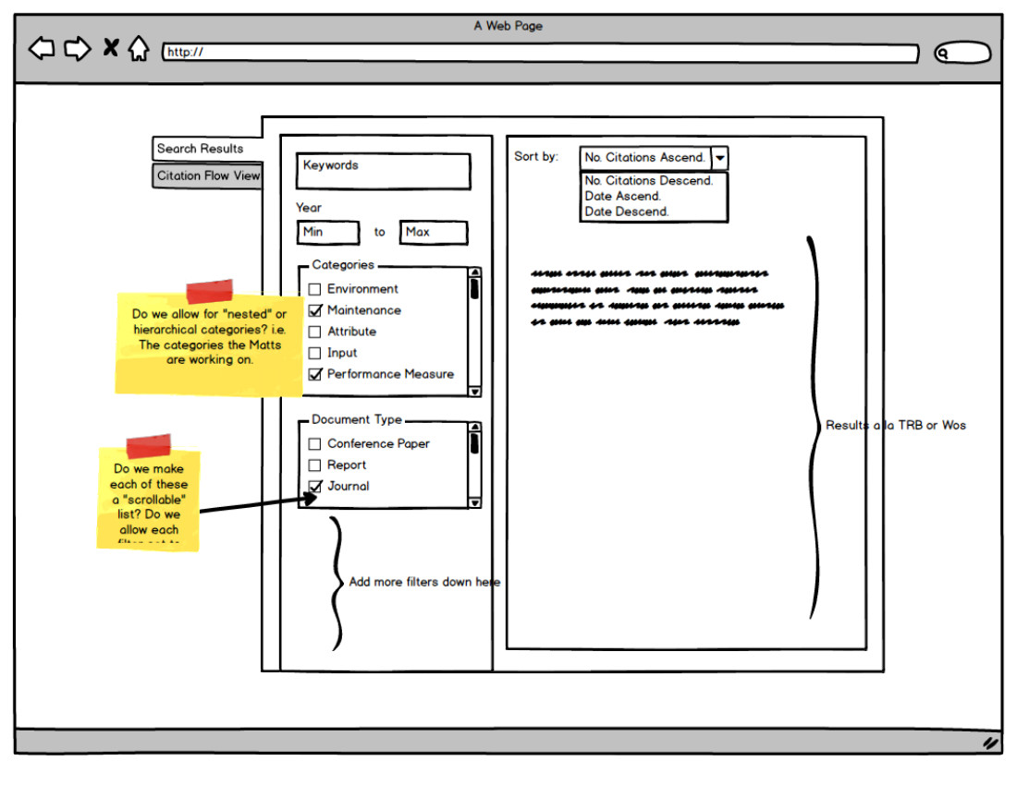

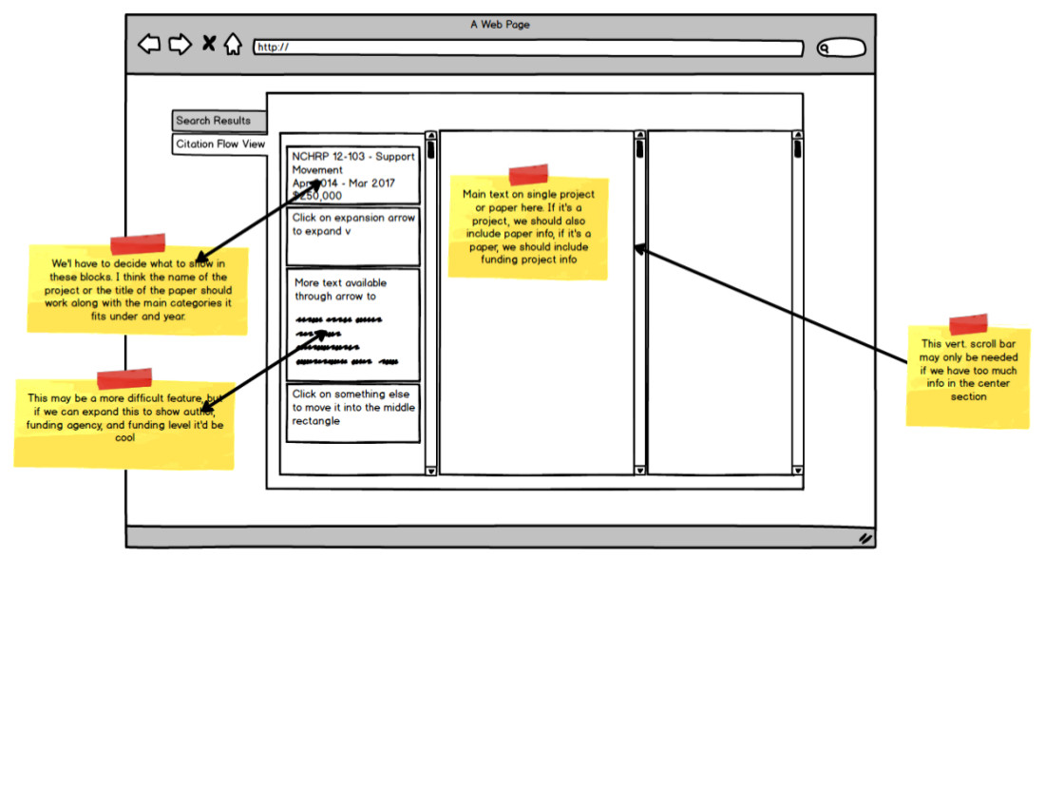

**Appendix B – Analyzed statistics for the data collection task- 1200 bridges (from the previous contract)**

**Appendix C – Bridge documentation statistical information**

Bridge Documentation Collection Statistics

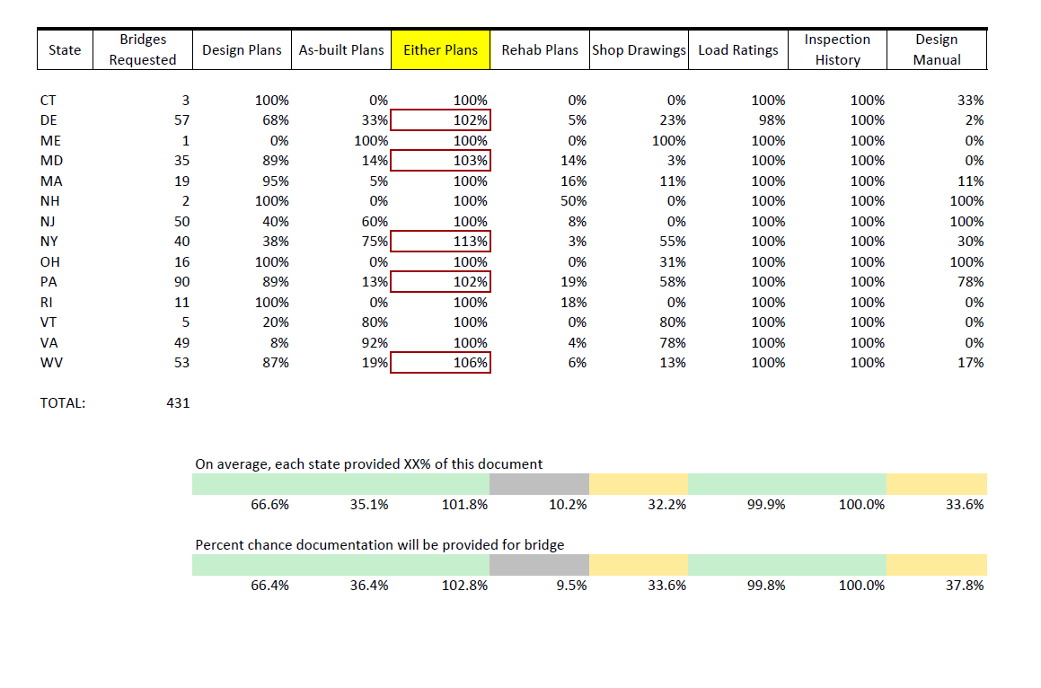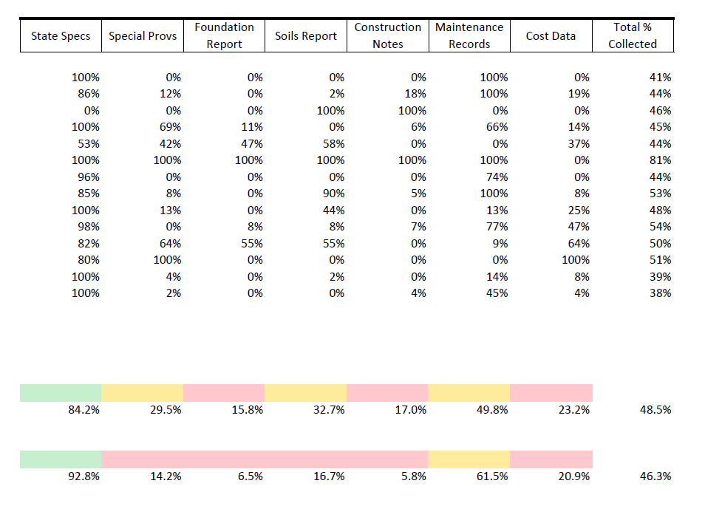

Average Percentage of Combined Documentation Requested from Each State

Percent Documentation Collected for Each Bridge

Individual Bridge Maintenance Records Collected from Each State

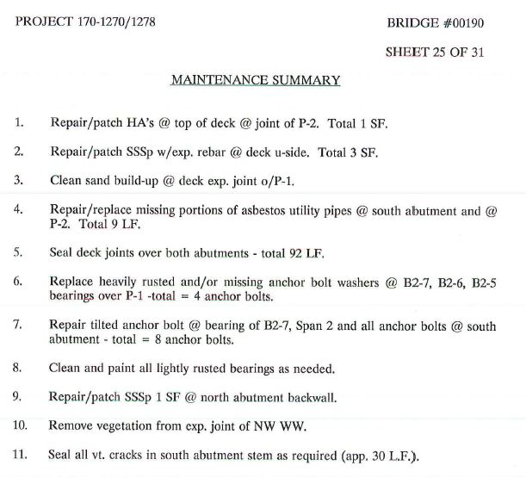

Example of a Poor Quality Maintenance Record

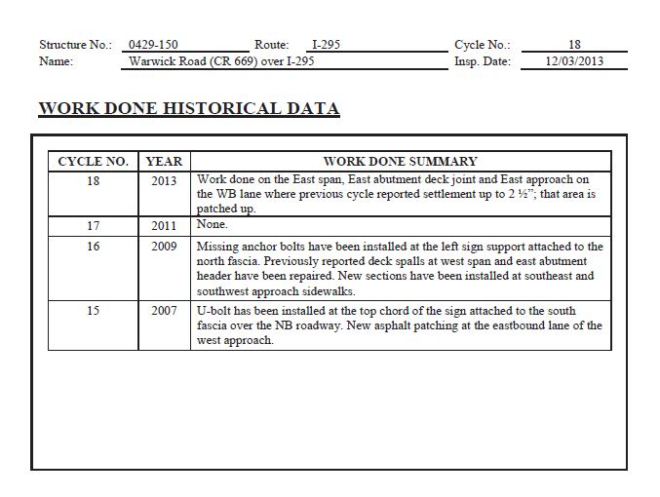

Example of an Average Quality Maintenance Record

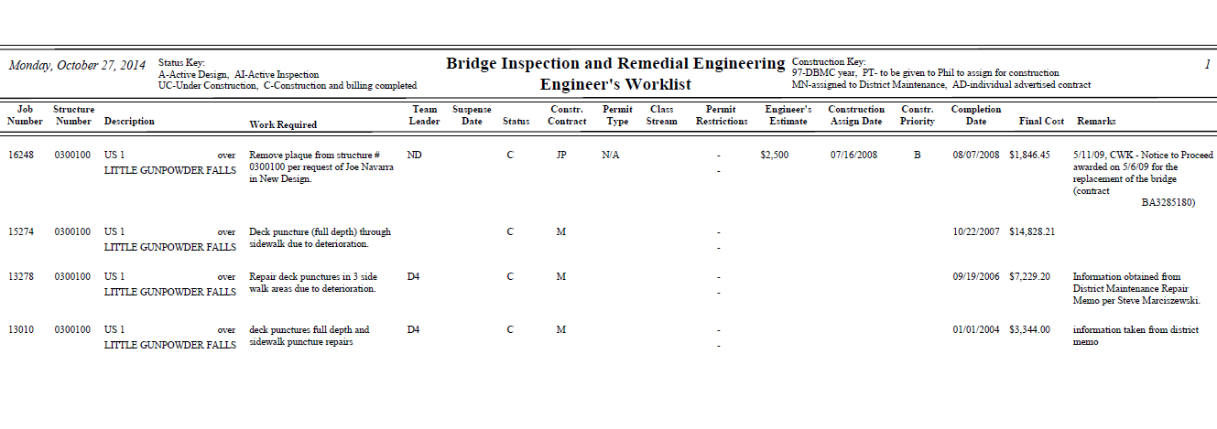

Example of a High-Quality Maintenance Record